**Validation of the User Login**

This document contains sections for:

● Sprint planning and Task completion

● Core concepts used in project

● Demonstrating the product capabilities, appearance, and user interactions.

The code for this project is hosted at <https://github.com/salabha77/ValidationOfTheUserLogin.git>

The project is developed by Salabha S.

**Development Environment**

* Eclipse IDE for Enterprise Java Developers vOxygen Release (4.7.0)
* Apache Tomcat Server v9.0
* JRE: OpenJDK Runtime Environment 1.8.0_202

**Sprints planning and Task completion**

The project is planned to be completed in 1 sprint. Tasks assumed to be completed in the sprint are:

• Initializing git repository to track changes as development progresses.

• Writing the Java program to fulfil the requirements of the project.

• Testing the Java program with different kinds of User input

• Pushing code to GitHub.

• Creating this specification document highlighting application capabilities, appearance, and user interactions.

**Core concepts used in project**

Servlets, Session-tracking

**Demonstrating the product capabilities, appearance, and user interactions**

To demonstrate the product capabilities, below are the sub-sections configured to highlight appearance and user interactions for the project:

1. Creating a maven project
2. Configuring pom.xml
3. Creating an HTML page
4. Creating a servlet
5. Configuring web.xml
6. Building the project
7. Publishing and starting the project
8. Running the project
9. Pushing the code to your GitHub repositories

**Step 1:** Creating a maven project

* Open Eclipse
* Go the **File** menu. Choose **New->Maven Project**
* Check the checkbox **Use default Workspace location.** Click on **Next**
* Select an Archetype as **Maven Webapp project.** Click on **Next**
* Enter **Specify Archetype parameters like Group Id, Artifact Id etc.** and click on **Finish**
* This will create the project files in the Project Explorer

**Step 2:** Configuring pom.xml

* In the Project Explorer, expand **ValidationOfTheUserLogin**
* Double click on **pom.xml** to open it in the editor
* Enter the following script:

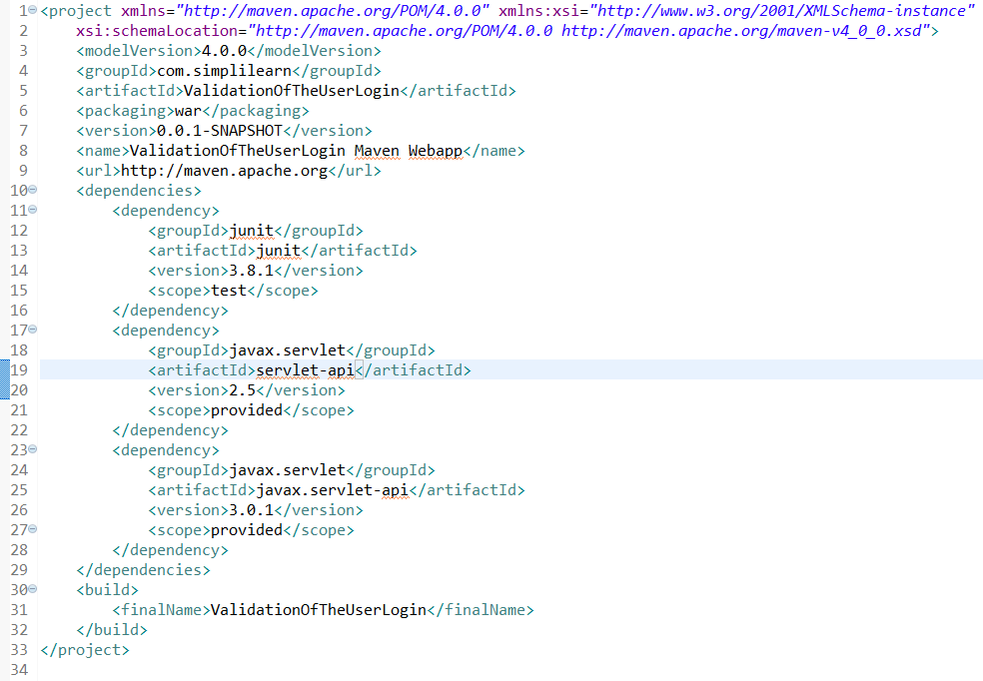

**Step 3:** Creating an HTML pages

* In the Project Explorer, expand the project 'ValidationOfTheUserLogin'
* Expand **src/main/webapp**. Right click on **webapp.** Choose **New->HTML File**
* Enter the filename as login.html and click on **Finish**
* Enter the following code:

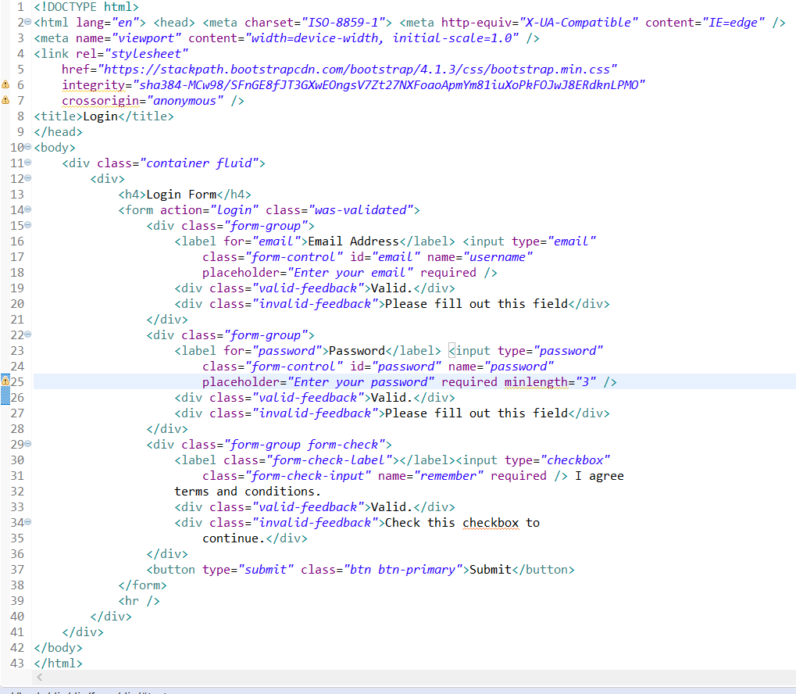

* Click on the **Save** icon
* In the Project Explorer, expand the project 'ValidationOfTheUserLogin'
* Expand **src/main/webapp**. Right click on **webapp.** Choose **New->HTML File**
* Enter the filename as index.html and click on **Finish**
* Enter the following code:

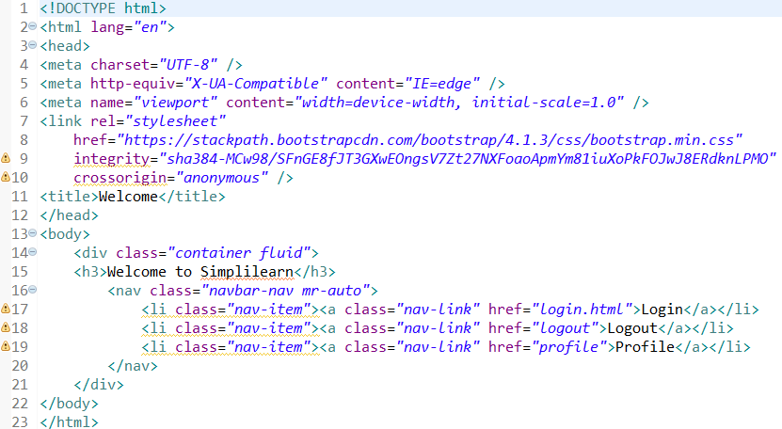

* Click on the **Save** icon
* In the Project Explorer, expand the project 'ValidationOfTheUserLogin'
* Expand **src/main/webapp**. Right click on **webapp.** Choose **New->HTML File**
* Enter the filename as link.html and click on **Finish**
* Enter the following code:

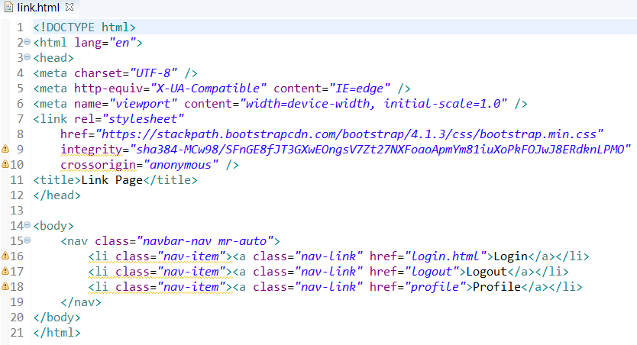

* Click on the **Save** icon

**Step 4:** Creating a servlet

* In the Project Explorer, expand **ValidationOfTheUserLogin->Java Resources->JacaSource**
* Right click on **src** and choose **New->Servlet**
* In **Class Name**, enter **NameServlet** and click on **Finish**
* Enter the following code:

**Login.java :-**

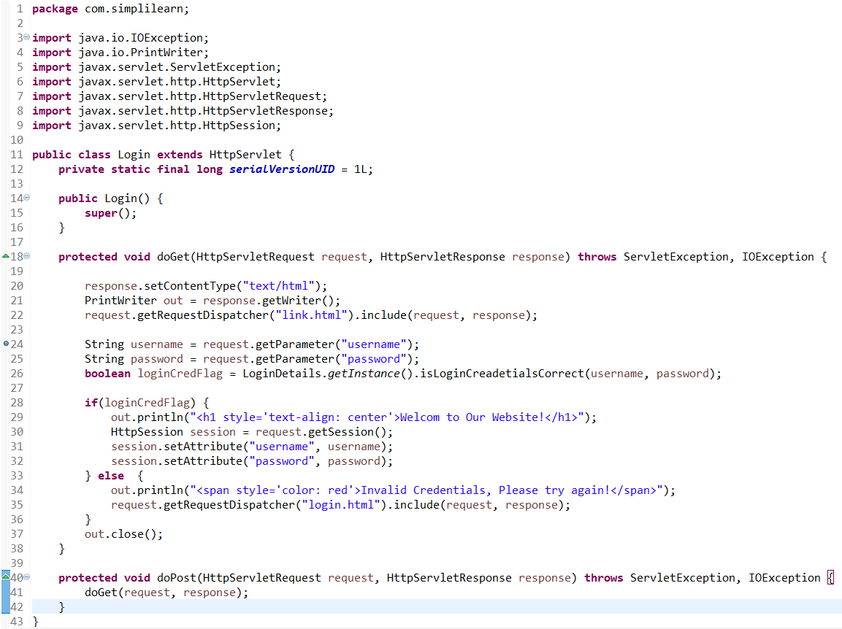

**LoginDetails.java :-**

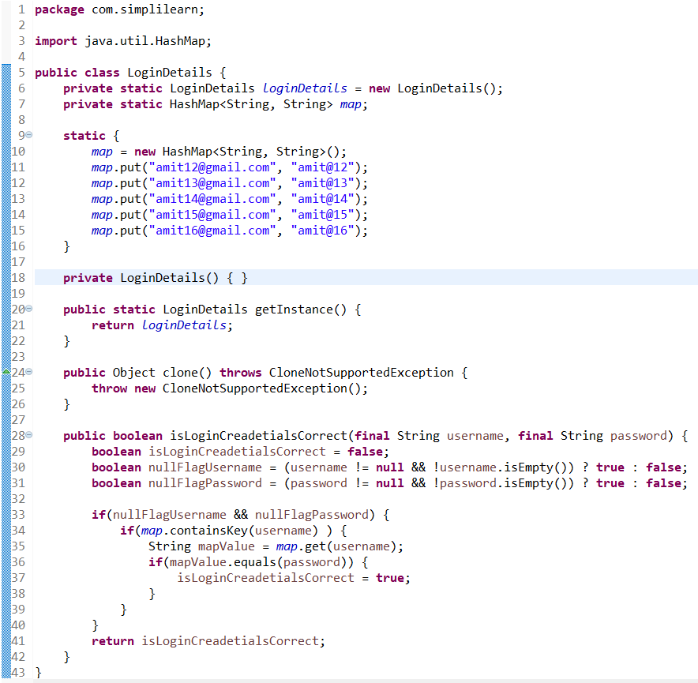

**Logout.java :-**

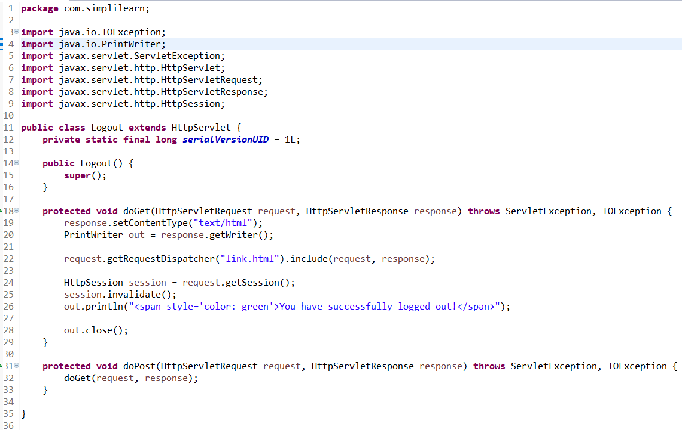

**Profile.java :-**

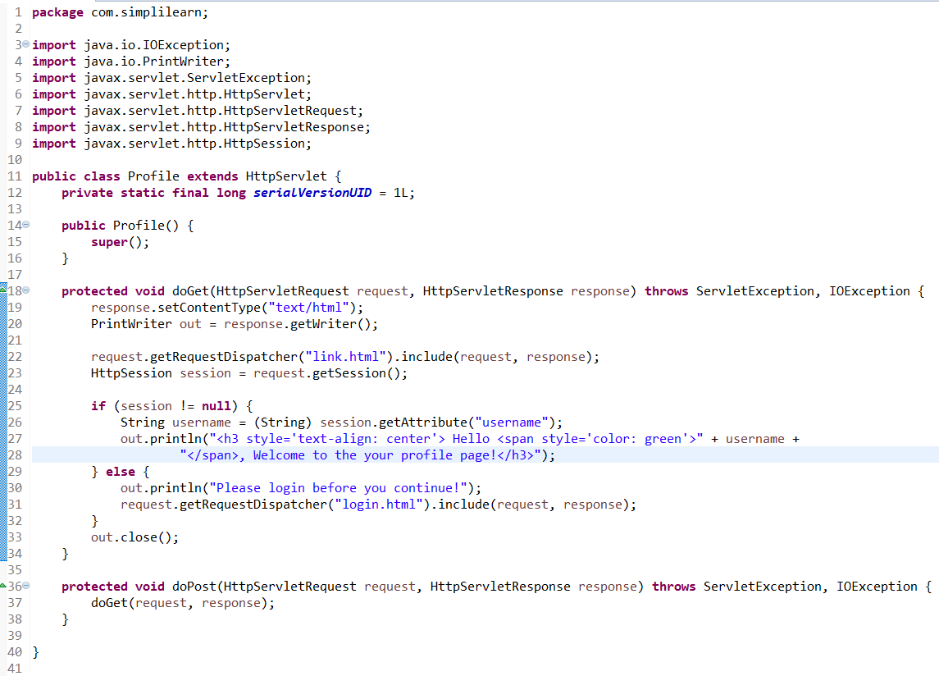

**Step 5:** Configuring web.xml

* In the Project Explorer, expand **ValidationOfTheUserLogin->src->main->webapp->WEB-INF**
* Double click on **web.xml** to open it in the editor
* Enter the following script:

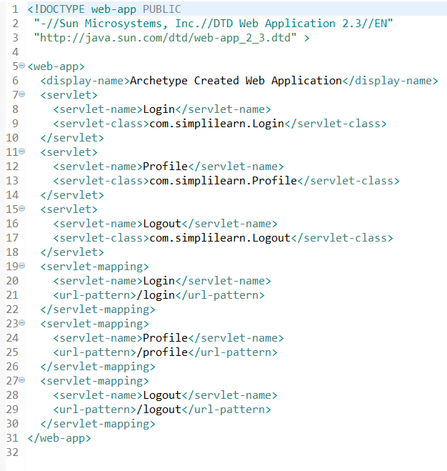

**Step 6:** Building the project

* From the **Project** menu at the top, click on **Build**
* If any compile errors are shown, fix them as required

**Step 7:** Publishing and starting the project

* If you do not see the **Servers** tab near the bottom of the IDE, go to **Window** menu and click on **Show View->Servers**
* Right click on the **Server** entry and choose **Add and Remove**
* Click the **Add** button to move **ValidationOfTheUserLogin** from the **Available** list to the **Configured** list
* Click on **Finish**
* Right click on the **Server** entry and click on **Publish**
* Right click the **Server** entry and click on **Start**
* This will start the server

**Step 8:** Running the project

* To run the project, open a web browser and type:

[**http://localhost:8080/ValidationOfTheUserLogin/login.html**](http://localhost:8080/ValidationOfTheUserLogin/login.html)

**Step 9:** Pushing the code to your GitHub repositories

* Open your command prompt and navigate to the folder where you have created your files.

**cd <folder path>**

* Initialize your repository using the following command:

**git init**

* Add all the files to your git repository using the following command:

**git add .**

* Commit the changes using the following command:

**git commit . -m “Changes have been committed.”**

* Push the files to the folder you initially created using the following command:

**git push -u origin master**